Ryan Miranda Barbosa 2ADSC  
RA:01232061  
  
Matteus Nogueira Bins 2ADSC  
RA: 01232118

Comandos Comuns  
  
Get-Help:  
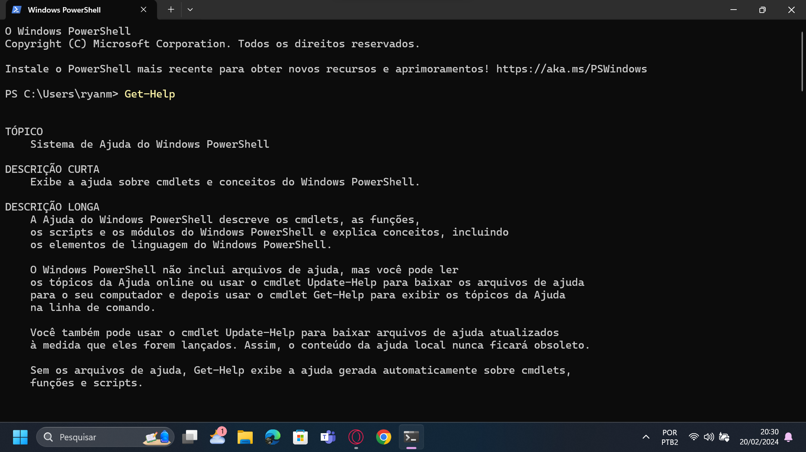  
  
Get-Help \*-Service  
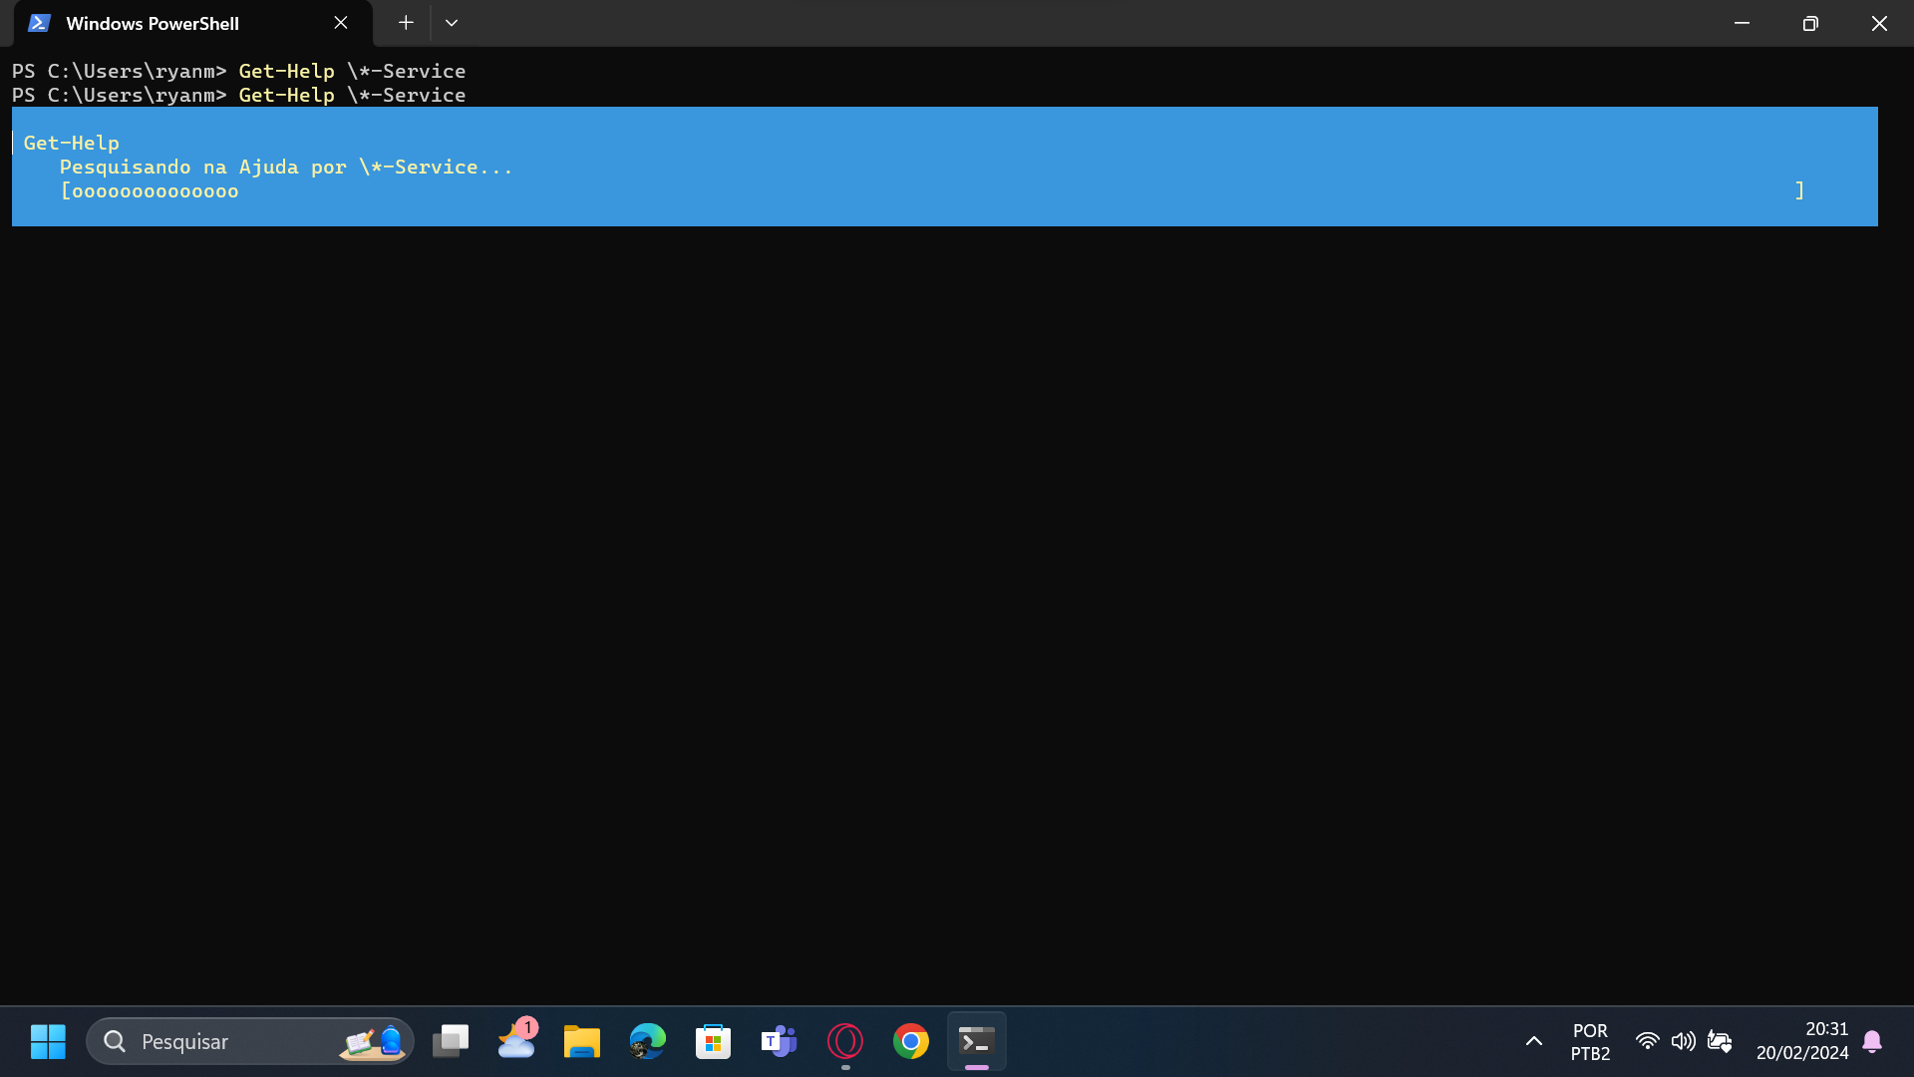  
  
cd:  
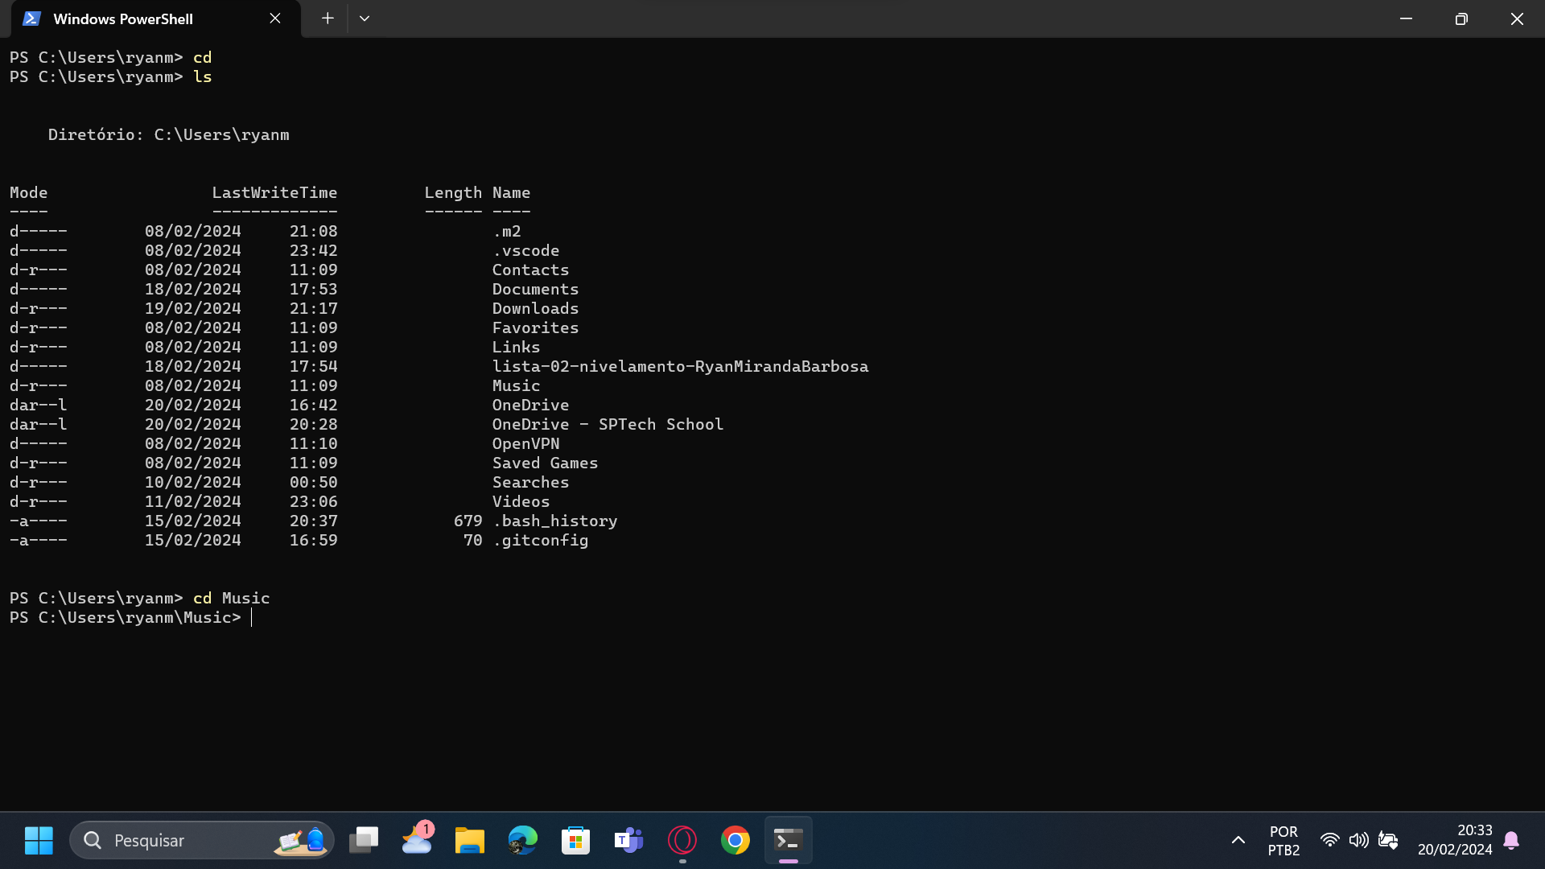

Dir:  
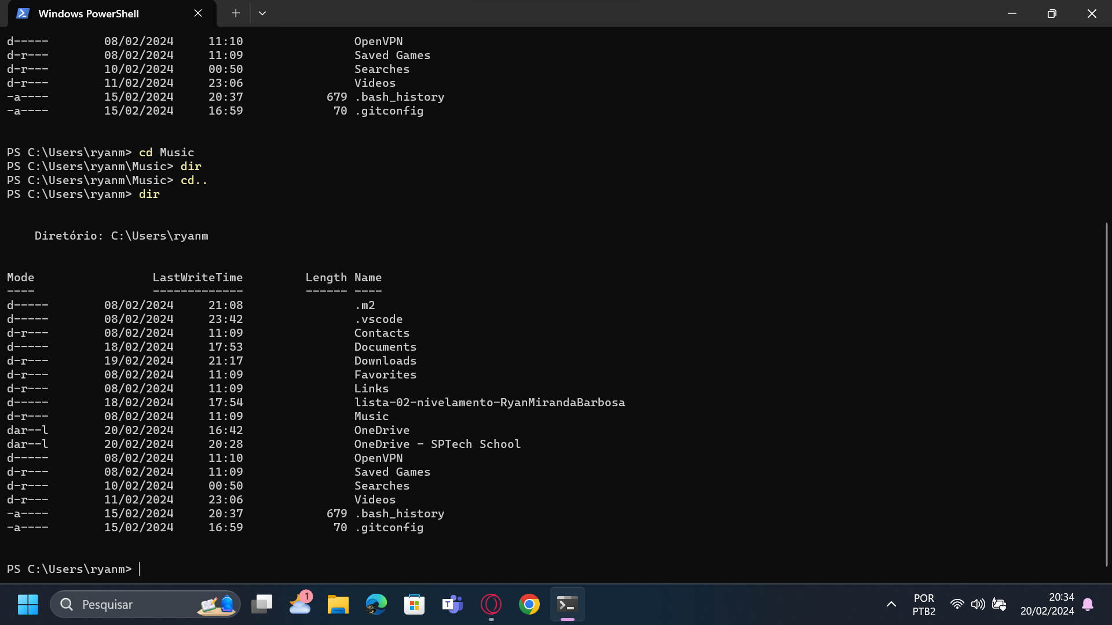  
  
Get-ChildItem:  
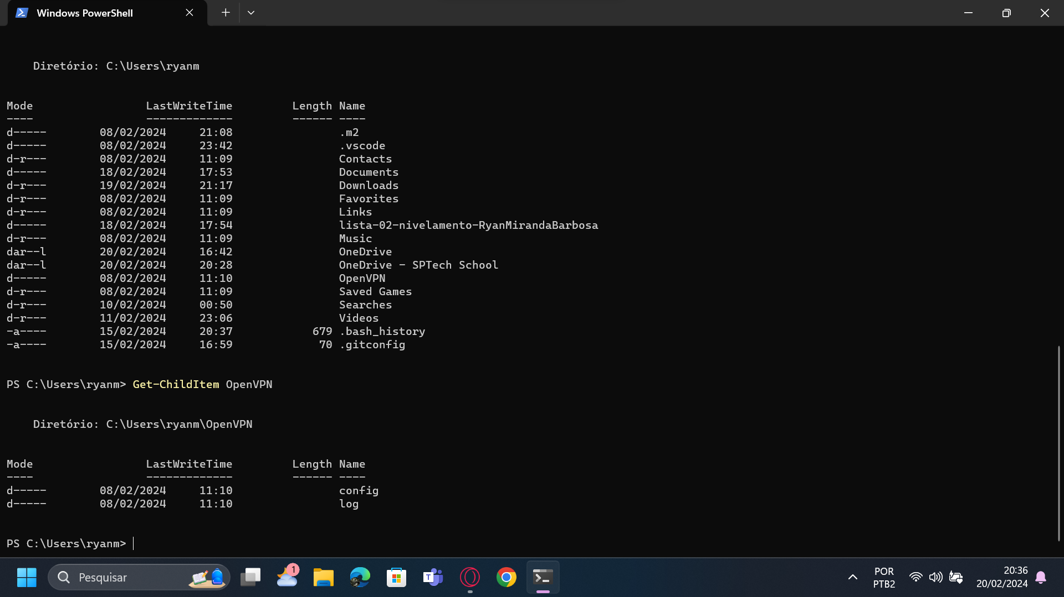  
New-Item –Path “ ” -Name “ ” –ItemType “ “  
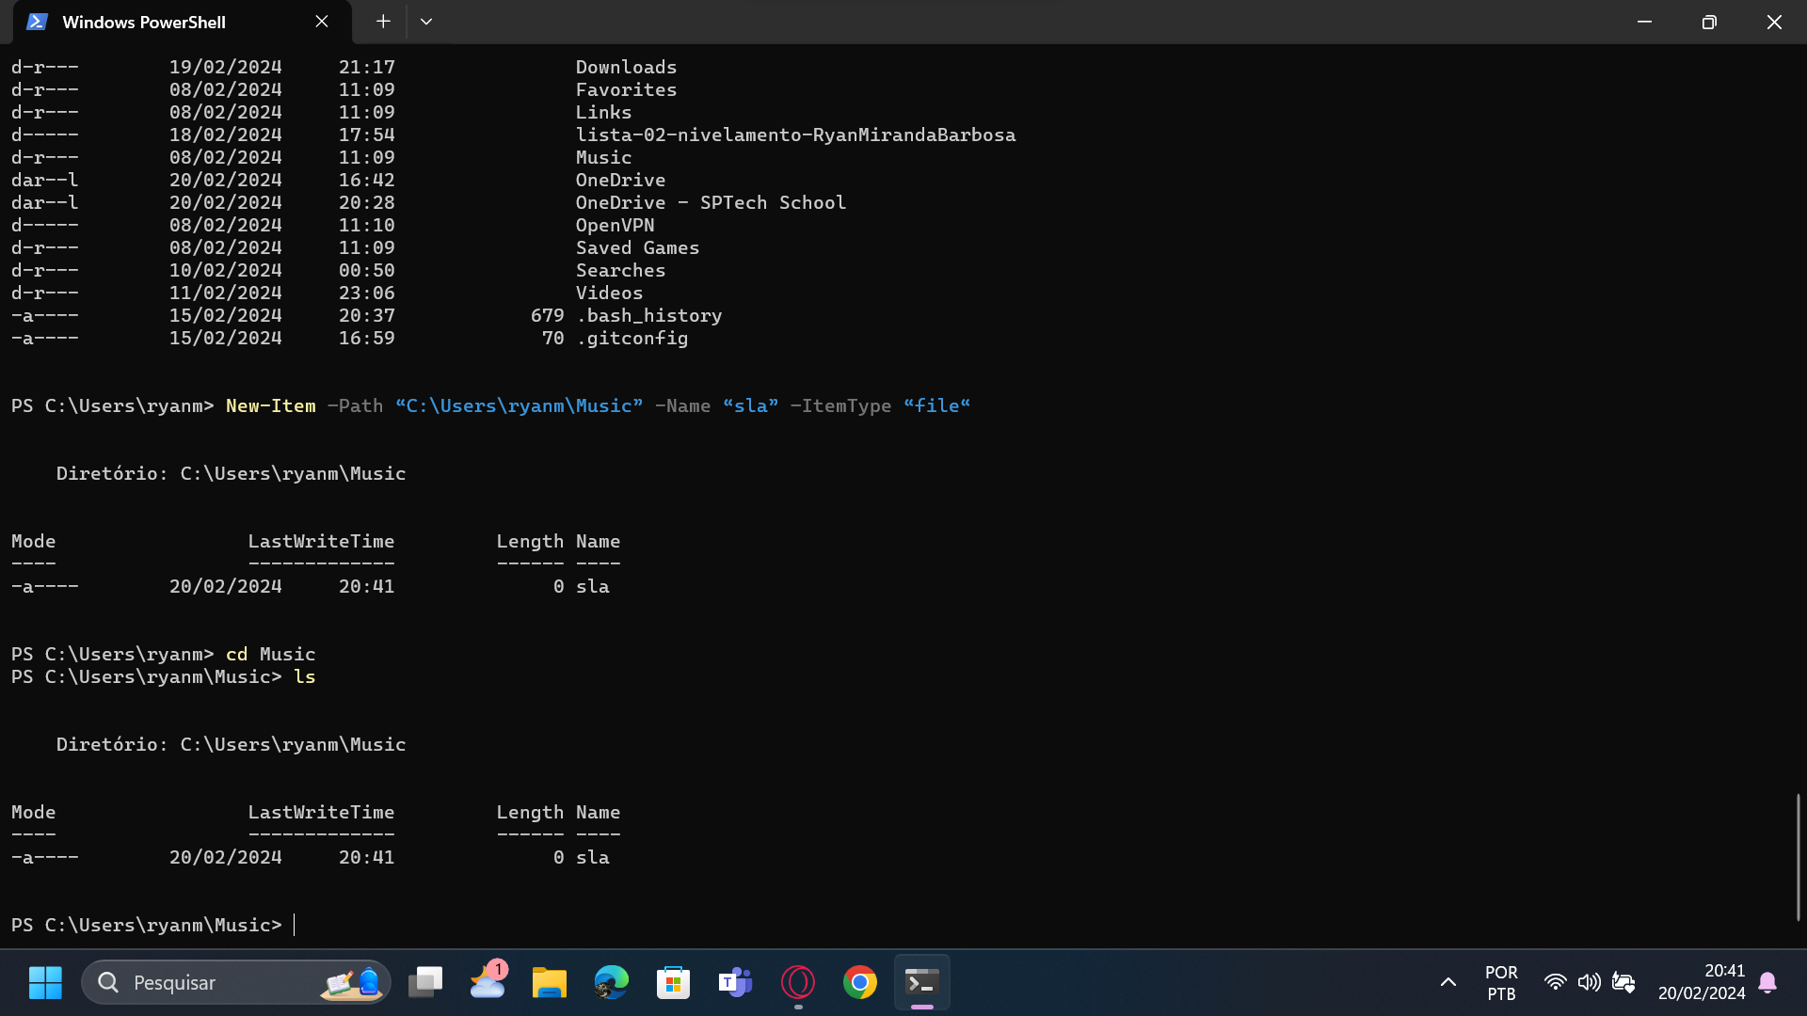

Remove-Item:  
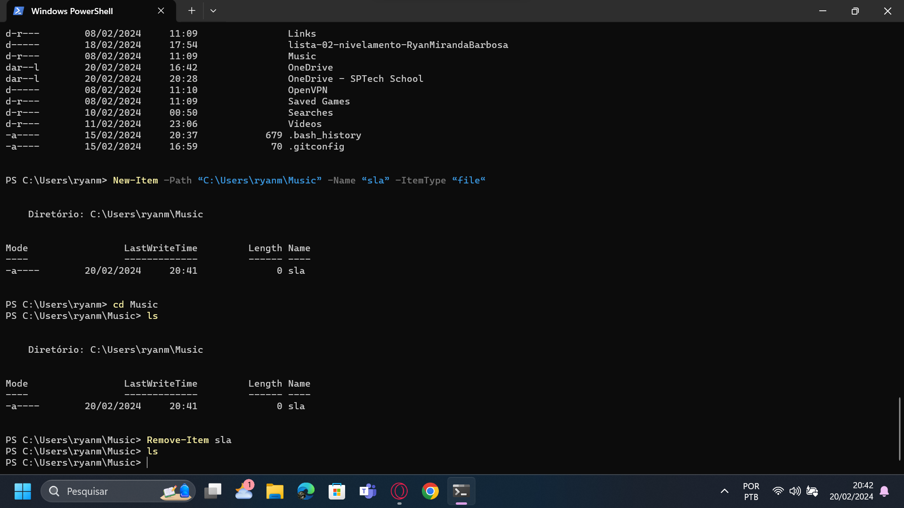  
  
Remove-Item “ “ –Recurse:  
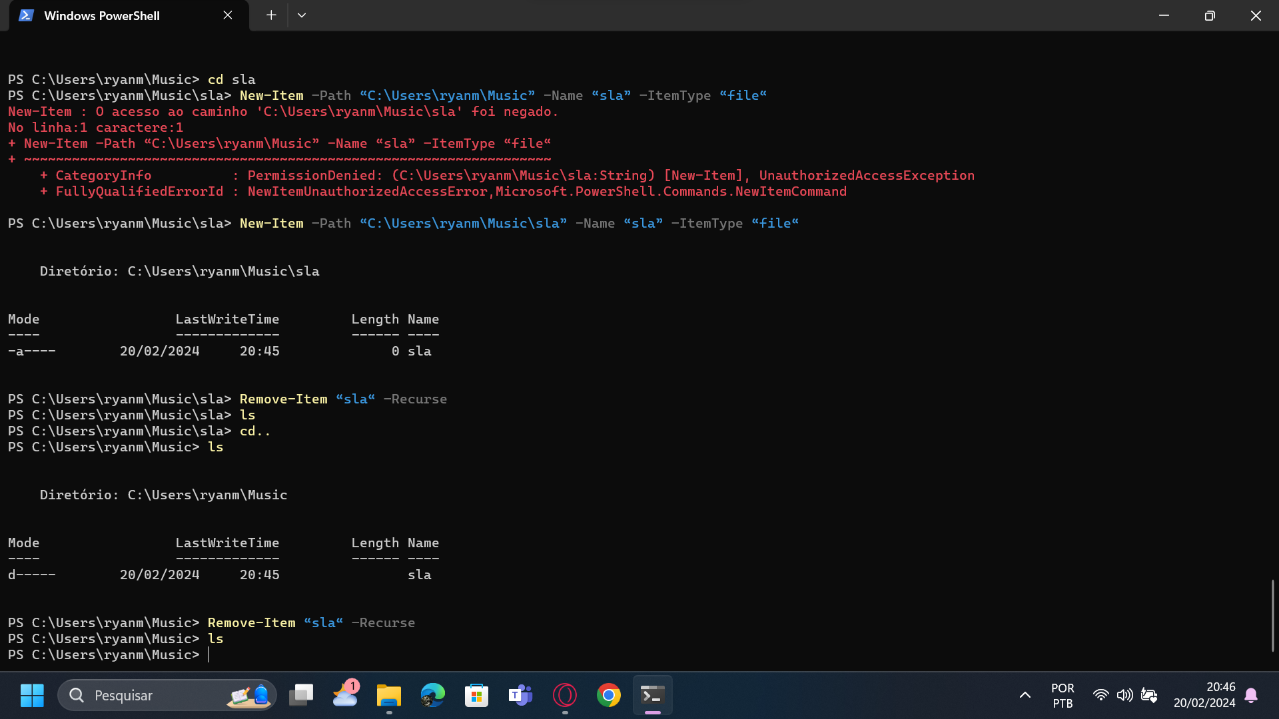  
  
ps:  
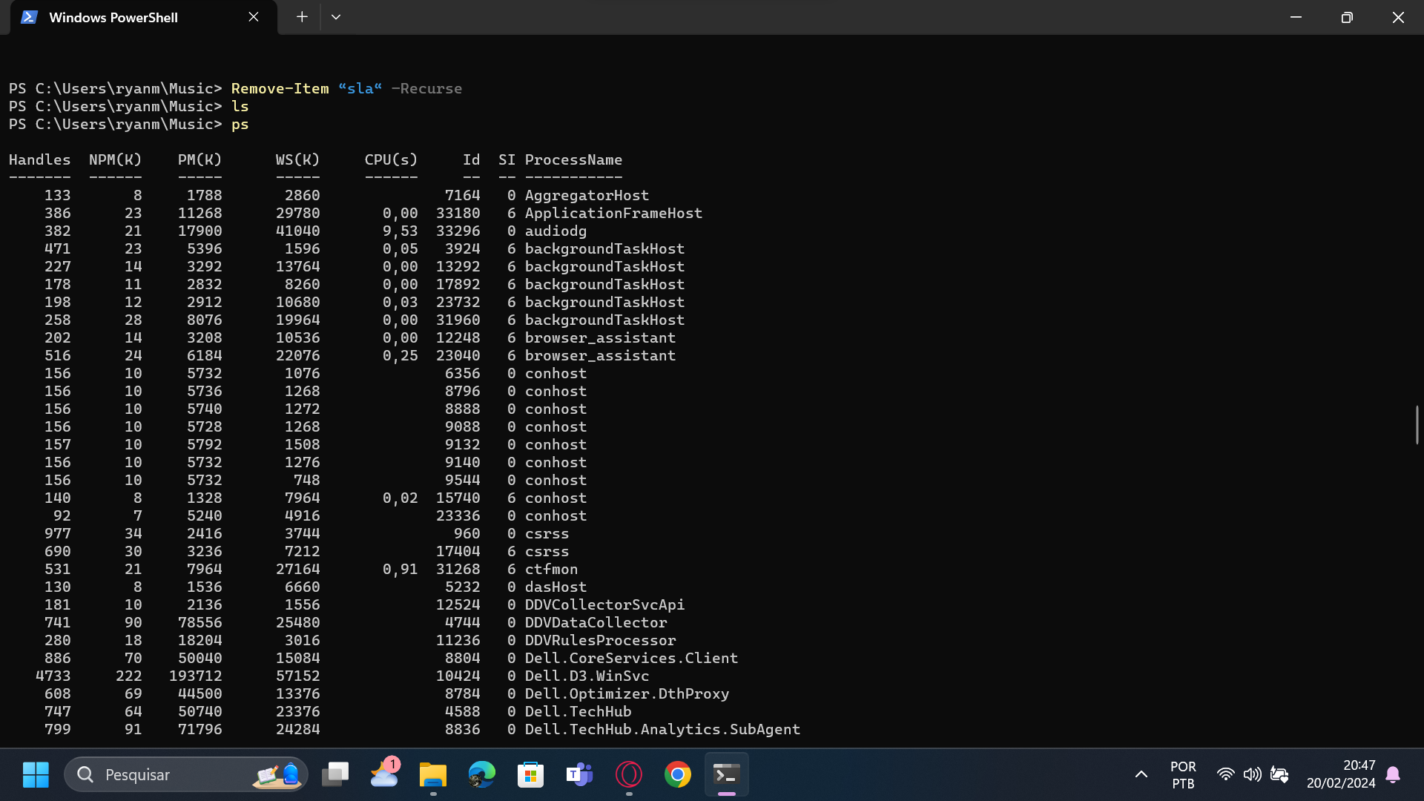  
  
ps | sort –p ws | select –last 5:  
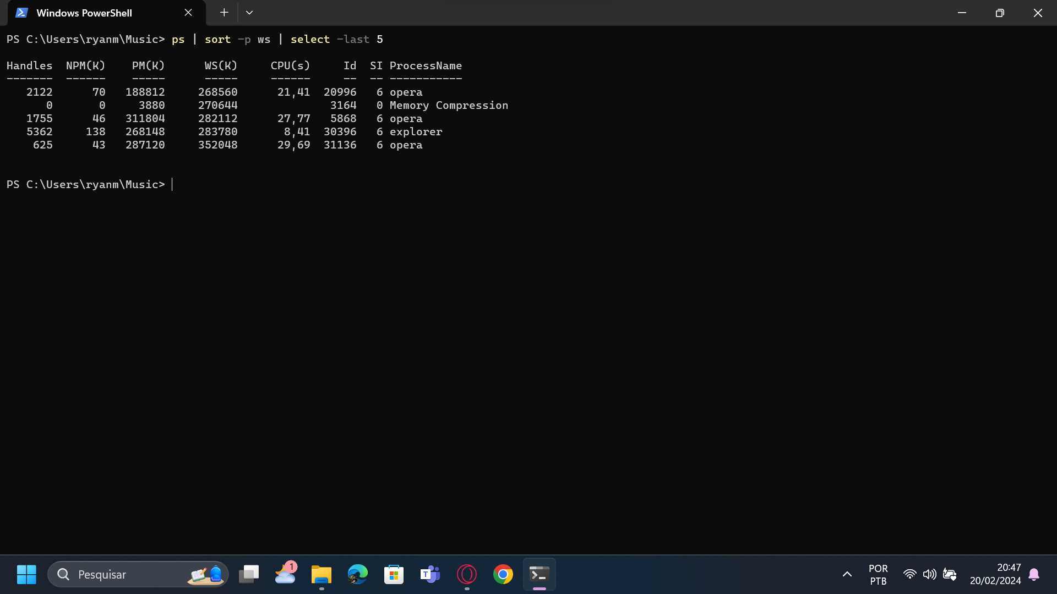  
  
Comandos Comuns  
Clear-host ou cls:  
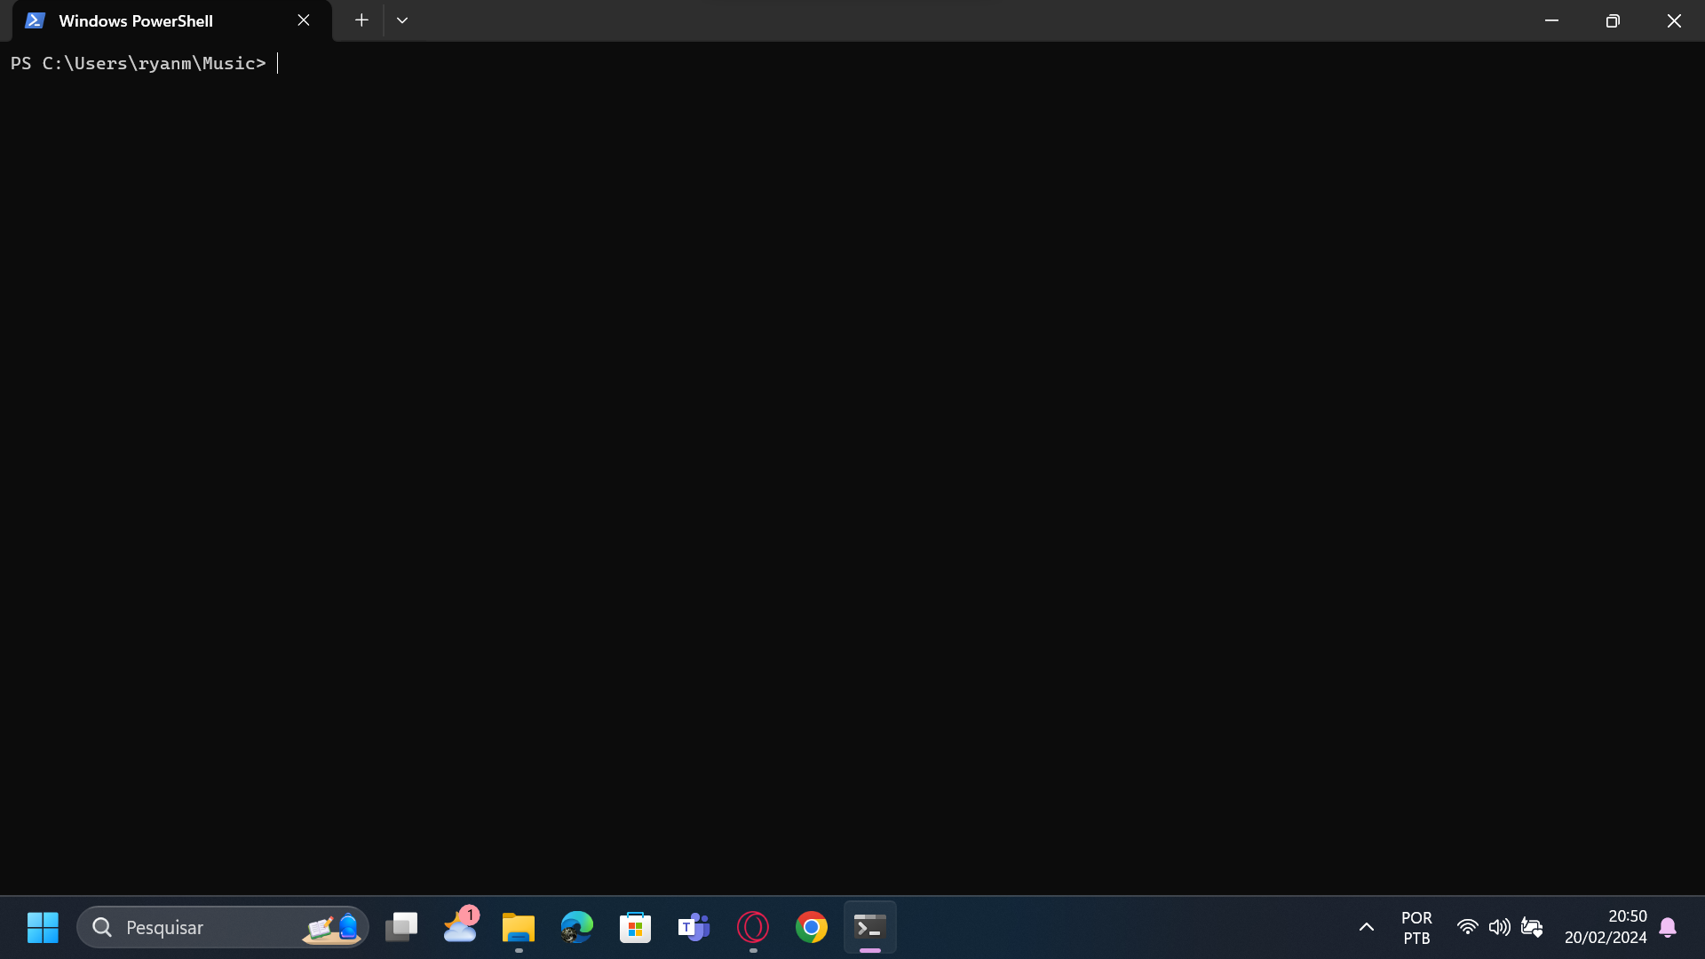  
  
Get-Command:  
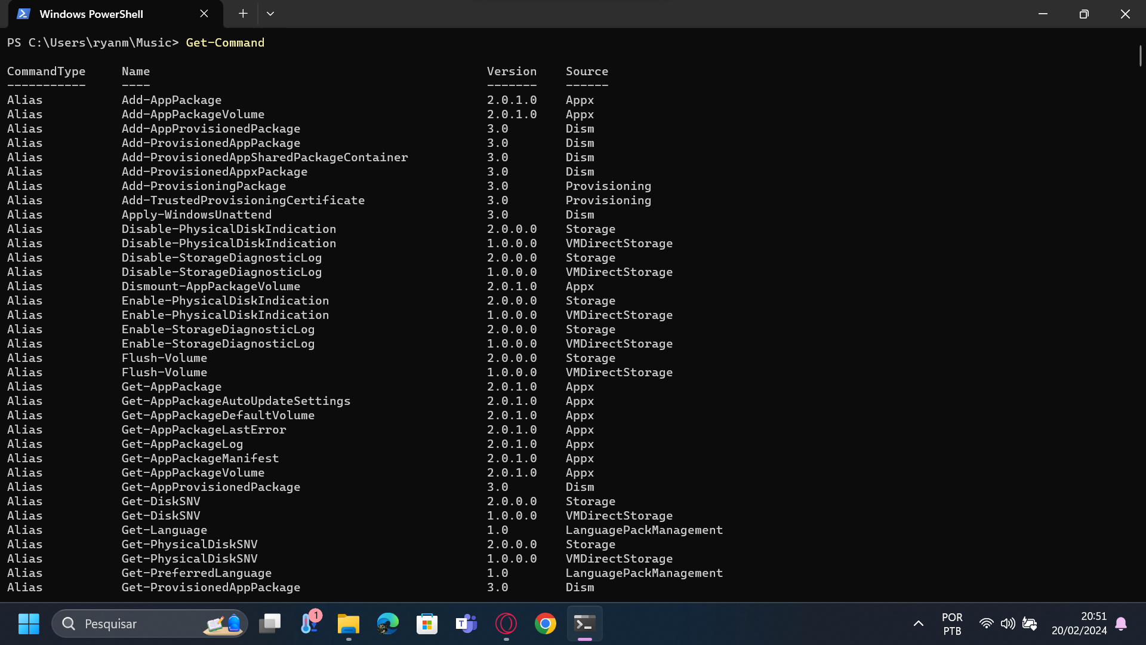  
  
$env:computername | Select-Object:  
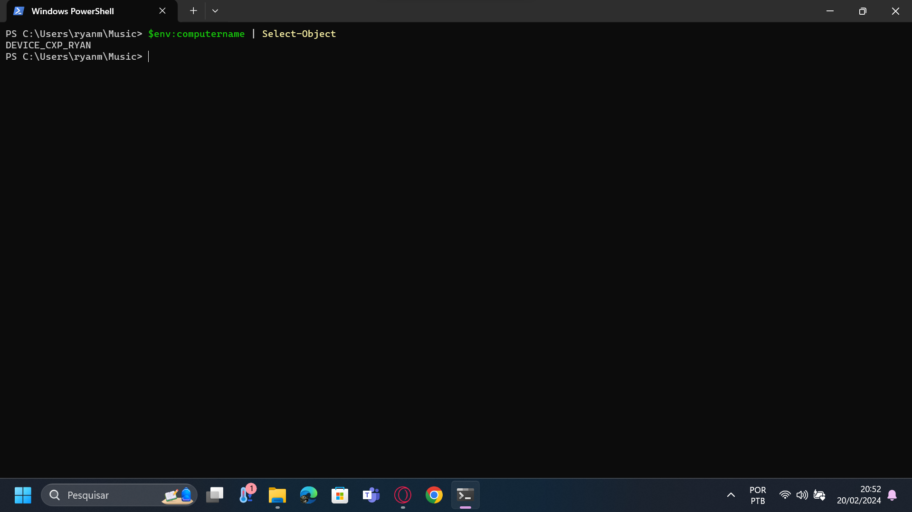  
  
Get-Process:  
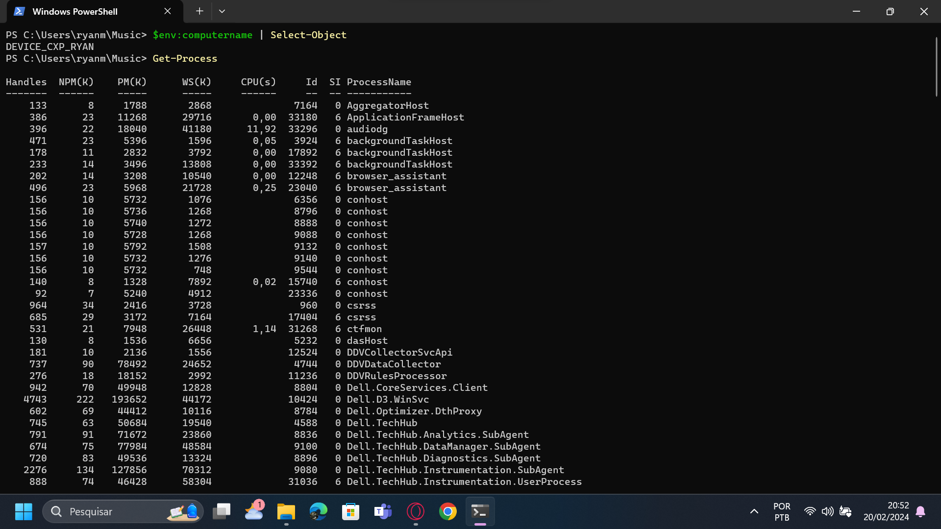  
  
mkdir:  
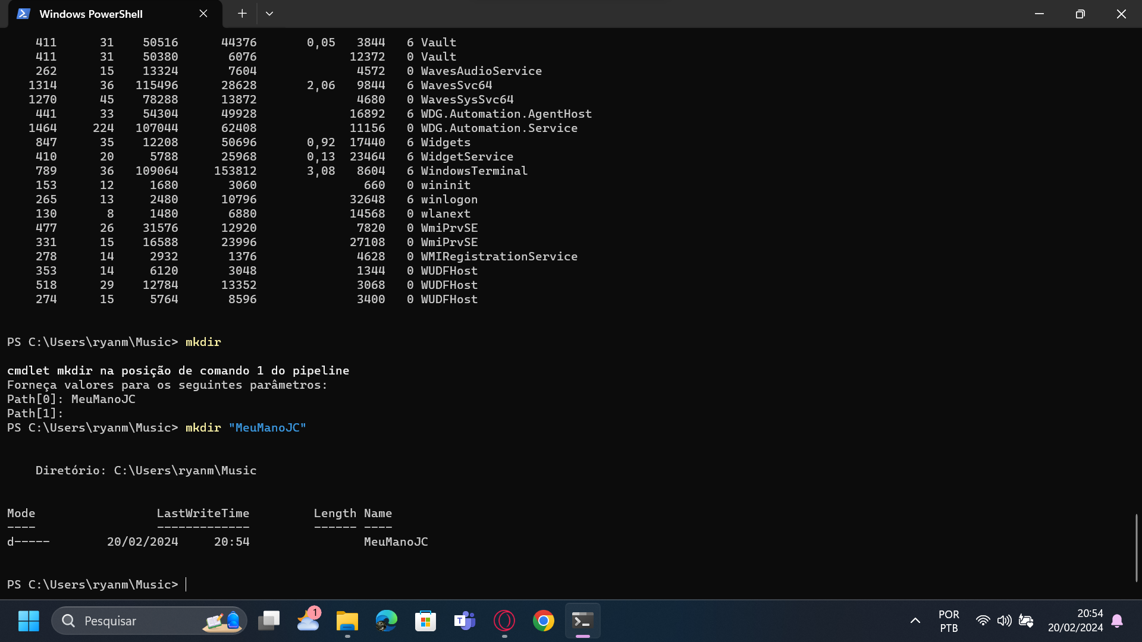  
  
Test-Path -Path "Path name“:  
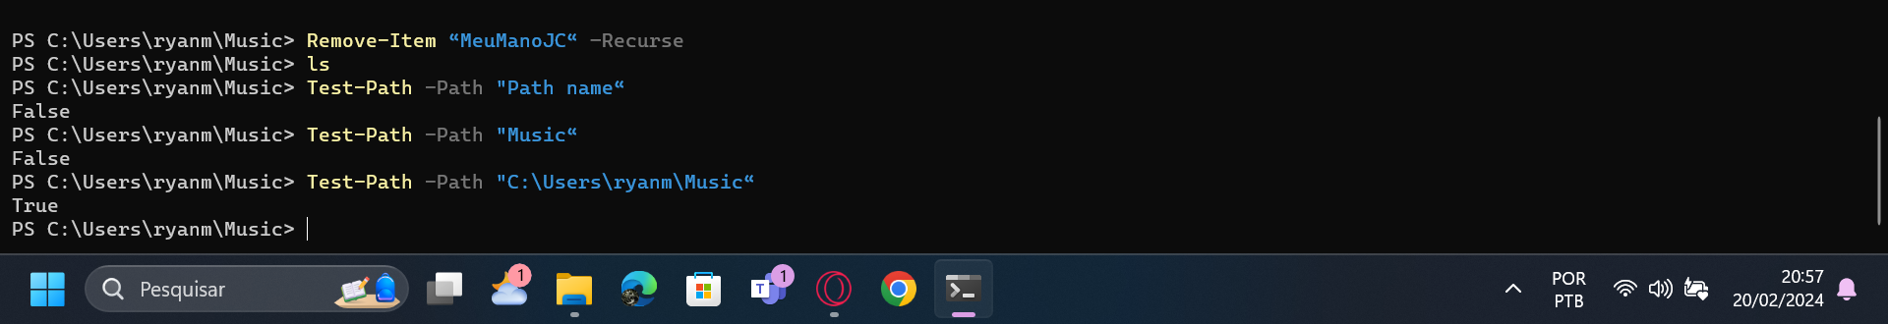  
  
Comandos para coletar informações

Get-WmiObject -Class Win32_ComputerSystem -Property UserName -ComputerName.:  
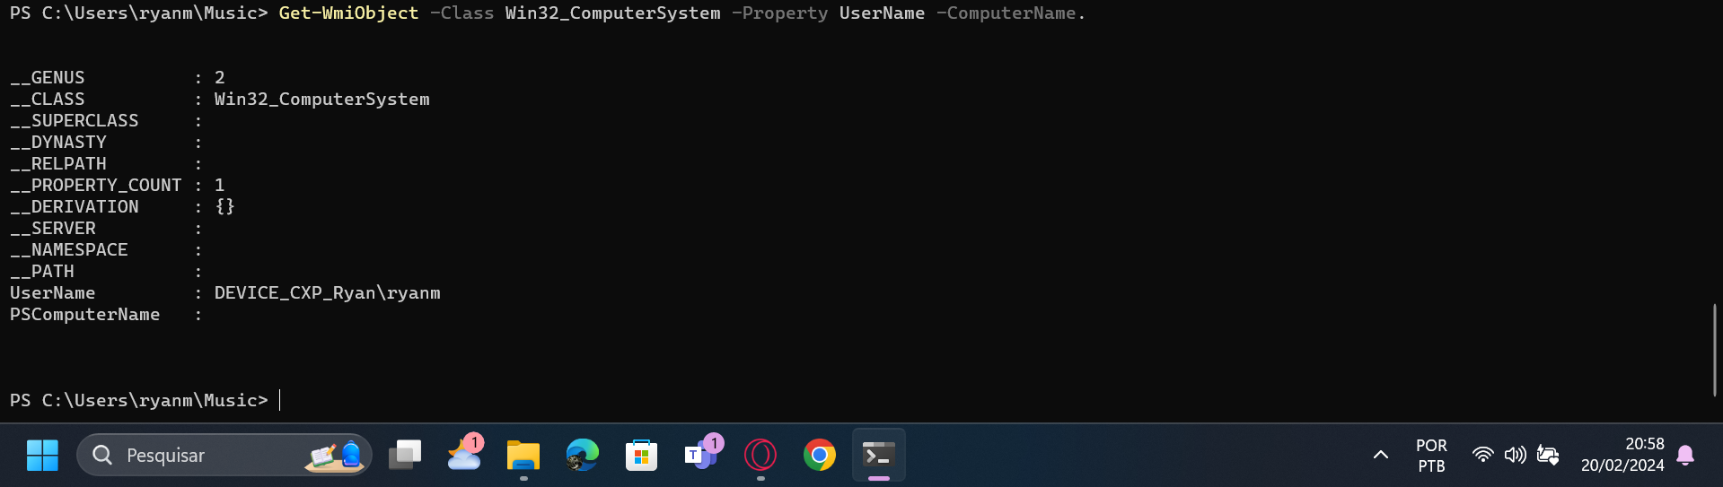  
  
driverquery:  
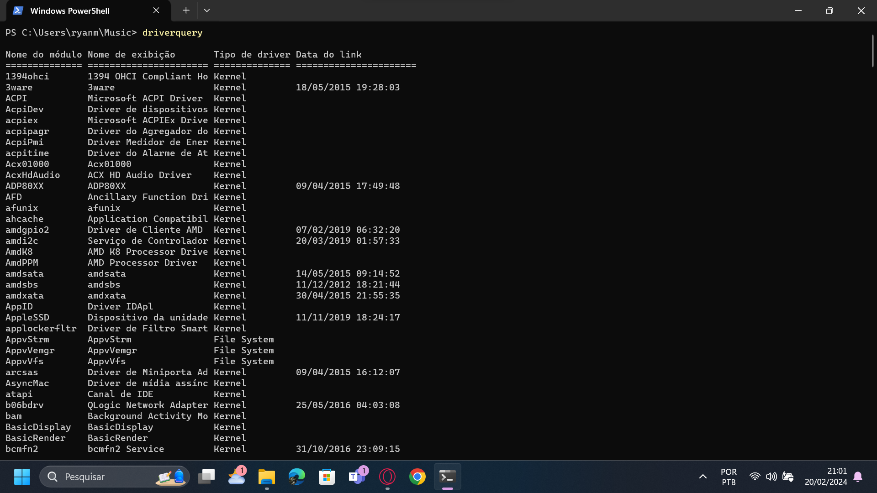  
  
Ipconfig:  
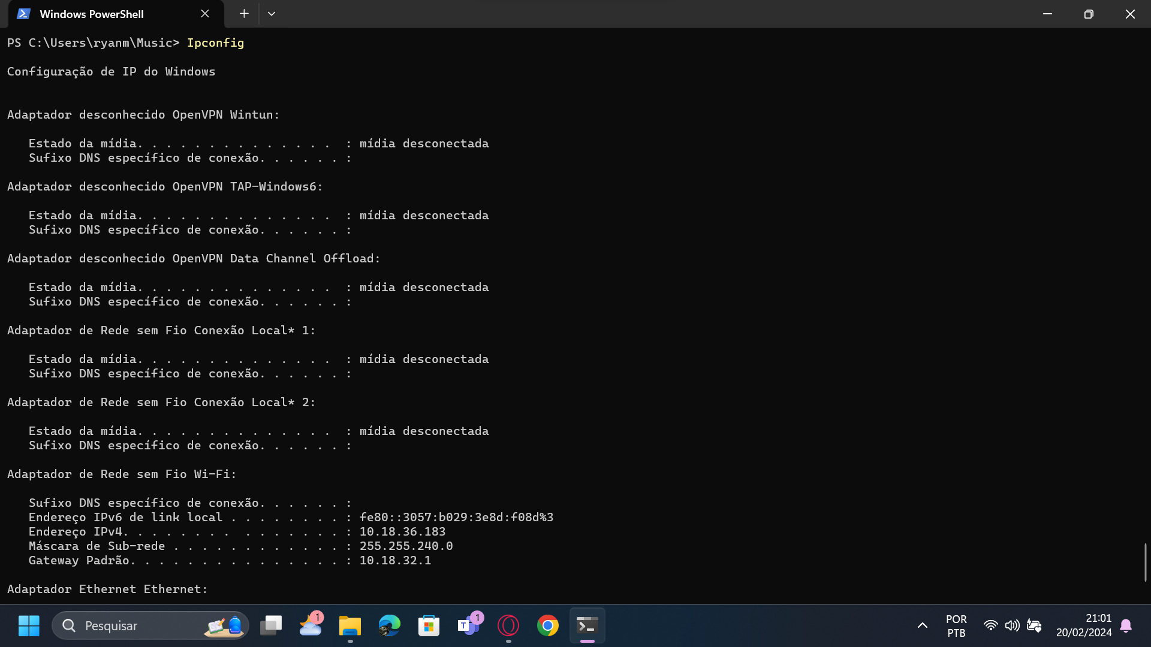

Powercfg /energy:  
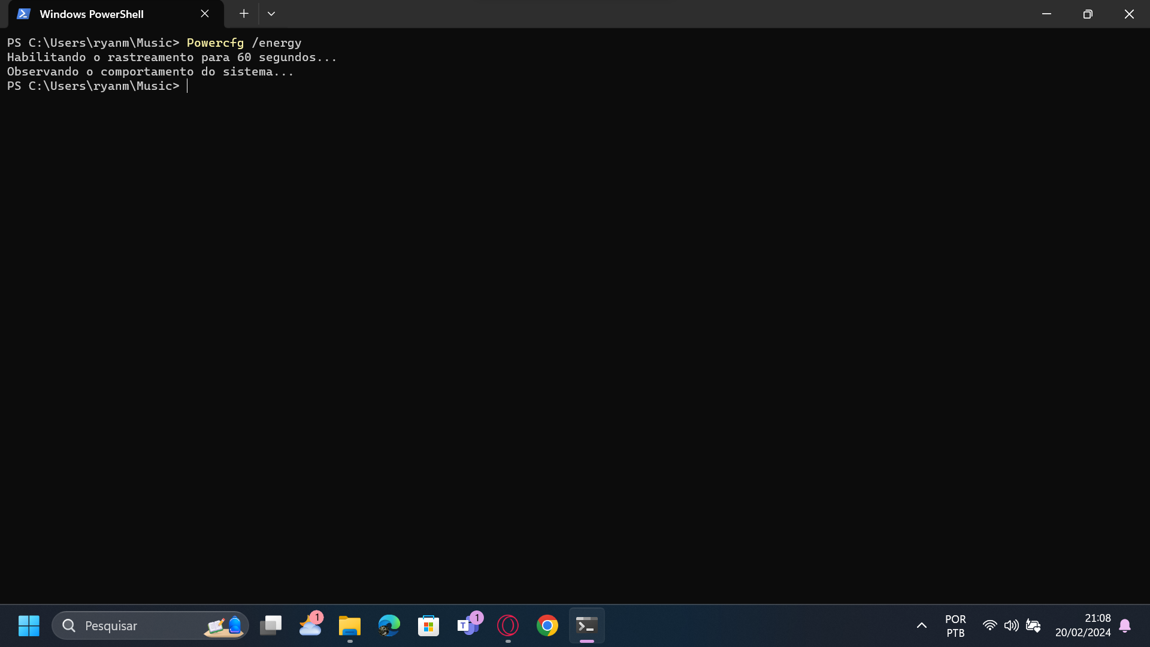  
  
Powercfg /batteryreport:  
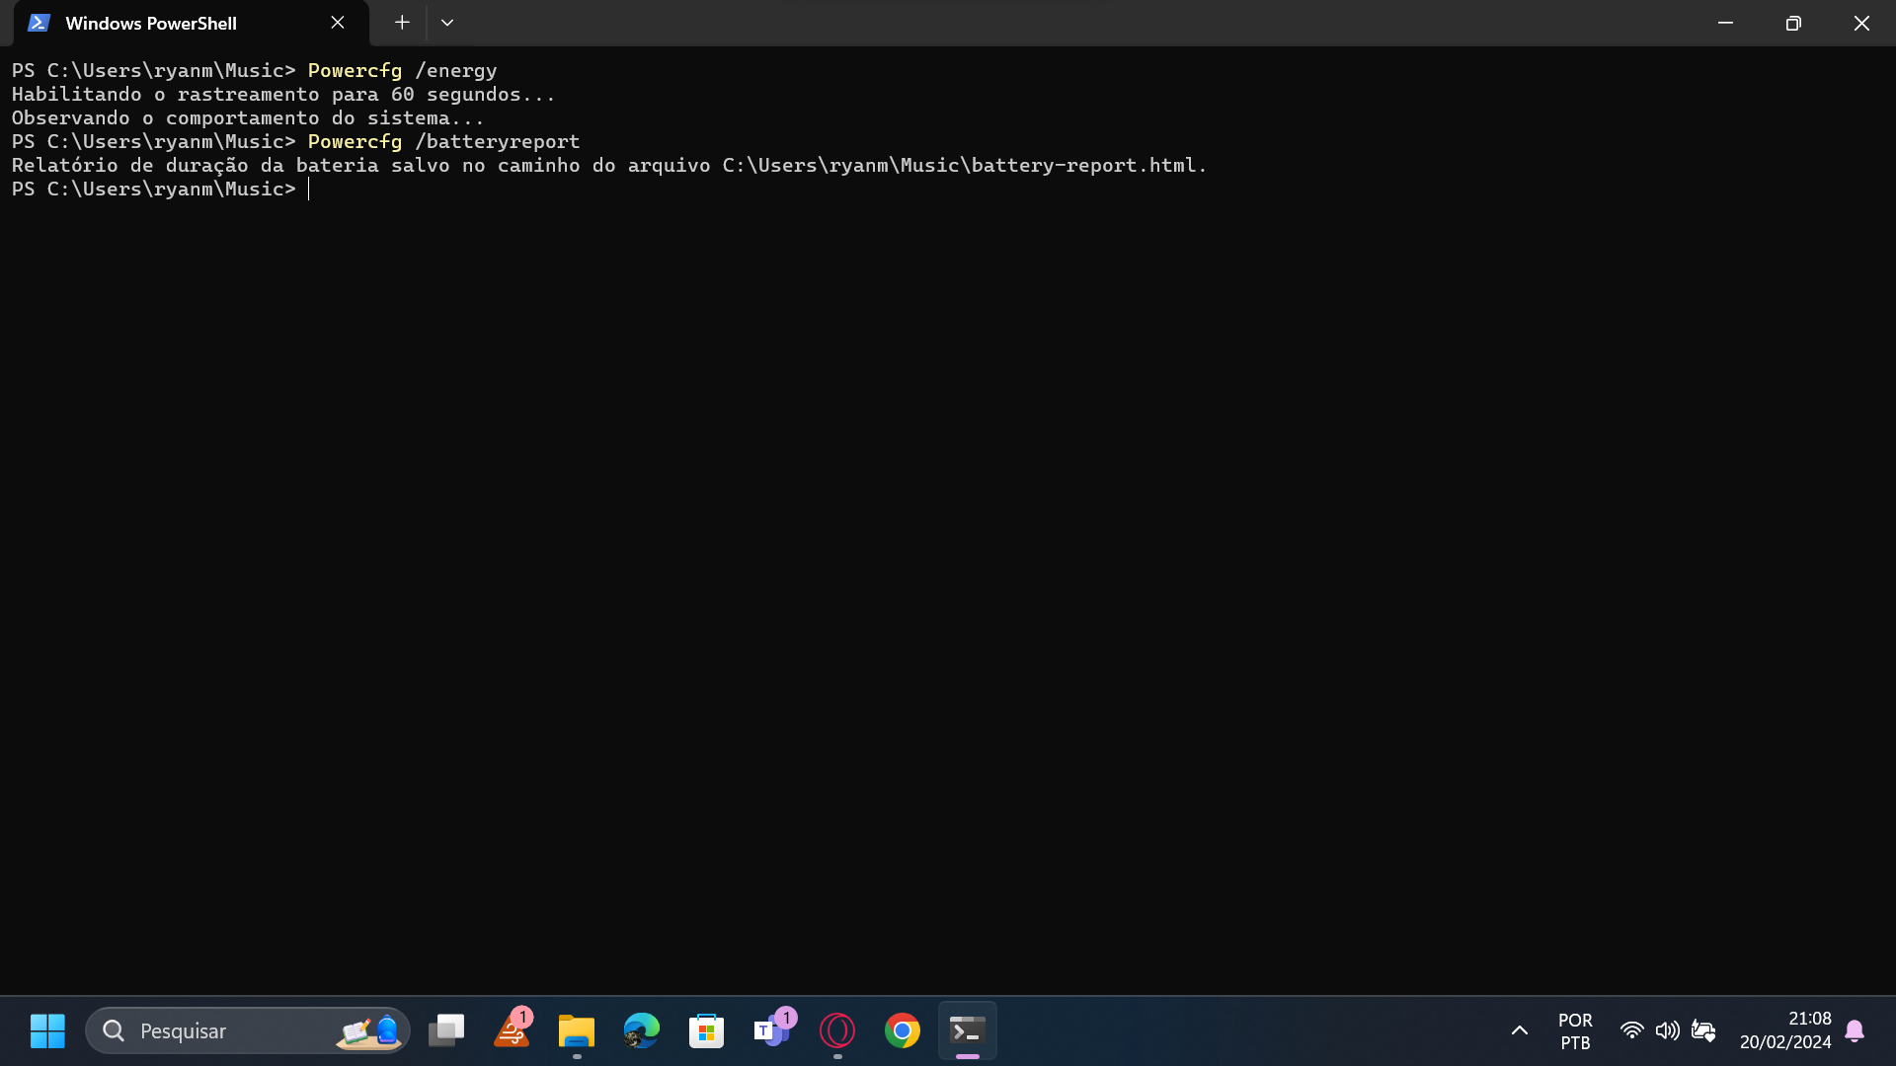  
  
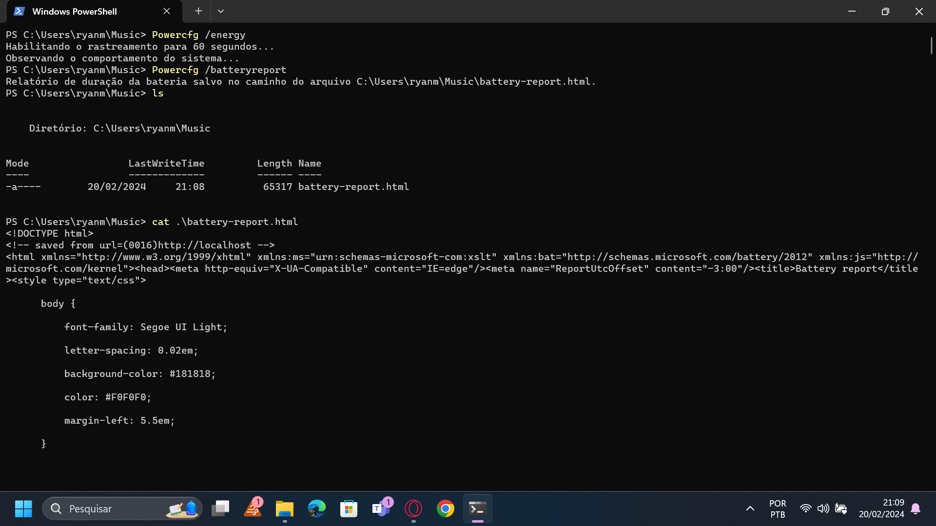  
systeminfo:  
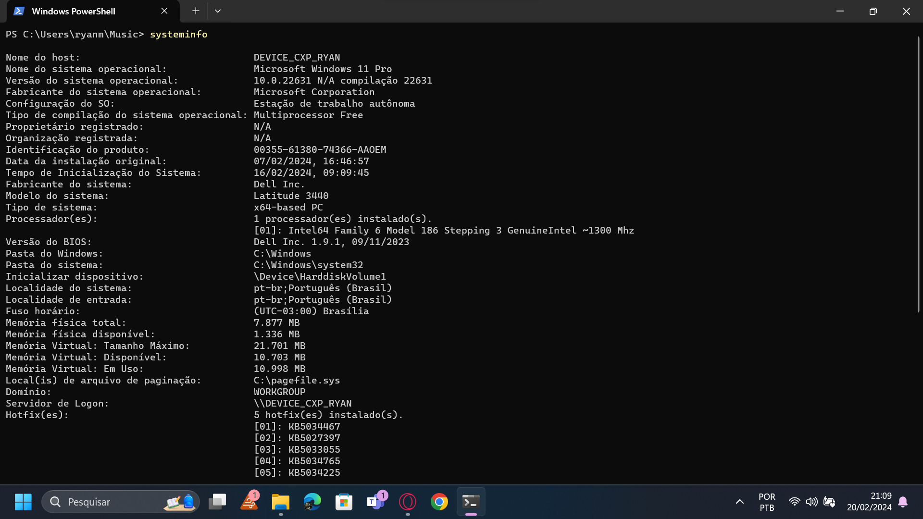  
  
sfc /scannow:  
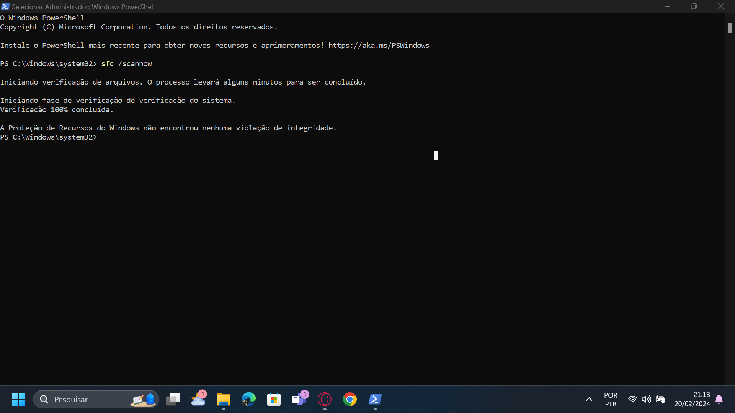  
  
Comandos para coletar Informações

Get-WmiObject -Class Win32_BIOS:  
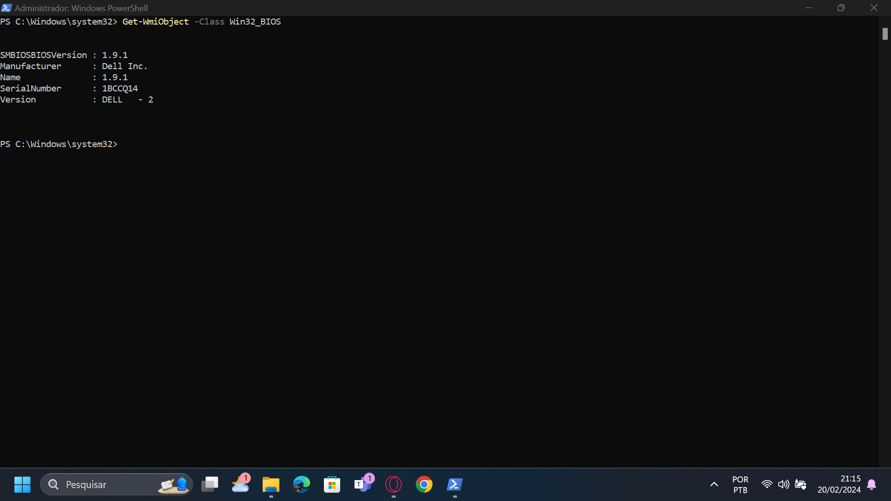  
  
Get-WmiObject -Class Win32_ComputerSystem:

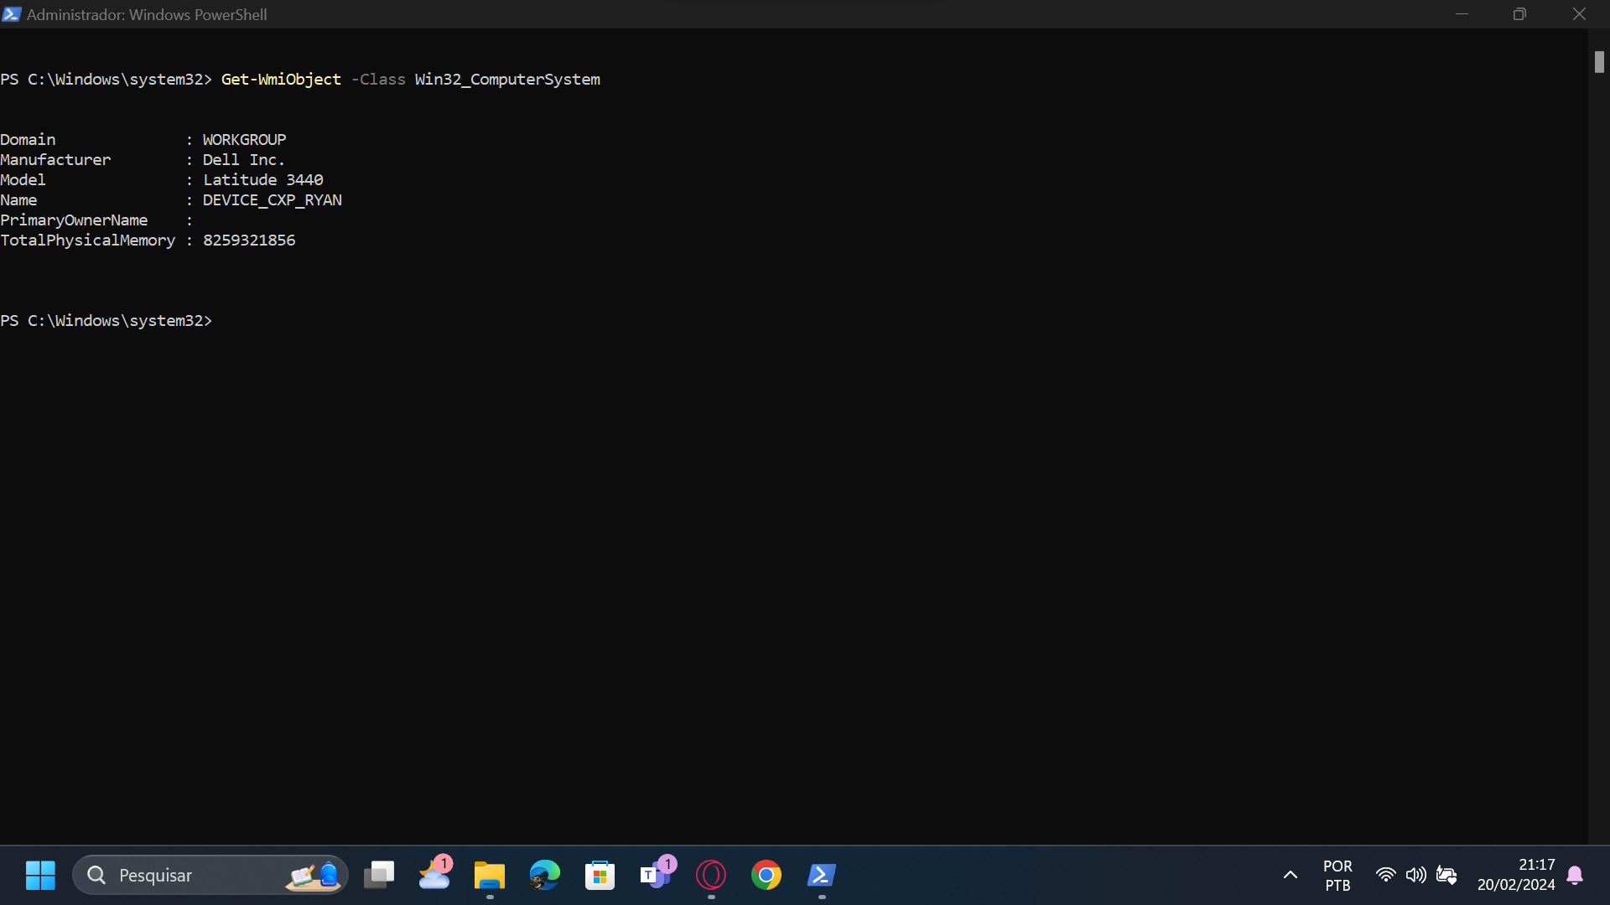  
  
Get-WmiObject -Class Win32_NetworkAdapterConfiguration:  
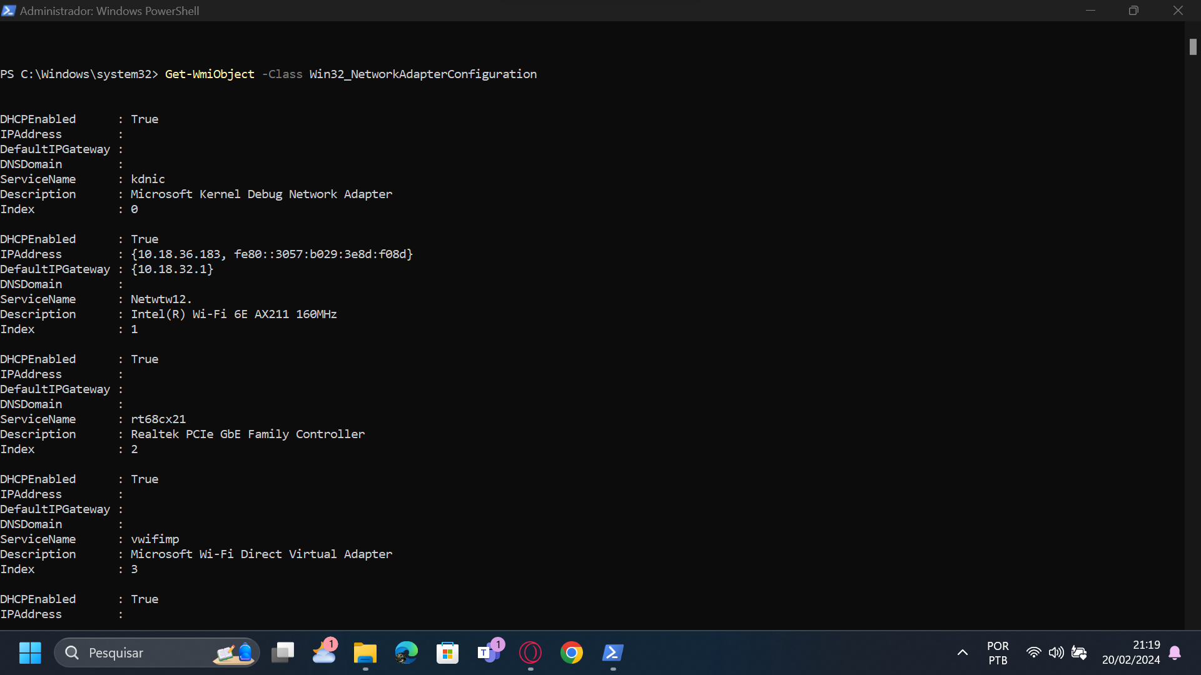

Get-WmiObject -Class Win32_NetworkAdapterConfiguration -Filter IPEnabled=TRUE -ComputerName . | Select-Object -Property IPAddress:  
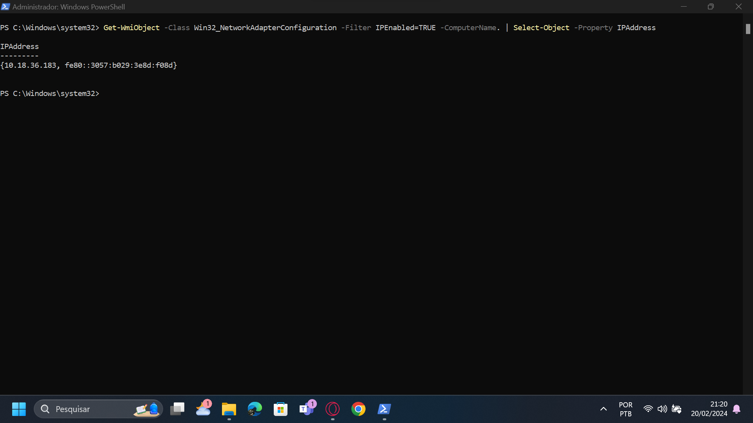  
  
Get-WmiObject Win32_NetworkAdapterConfiguration | format-table IPAddress, Description –autosize:  
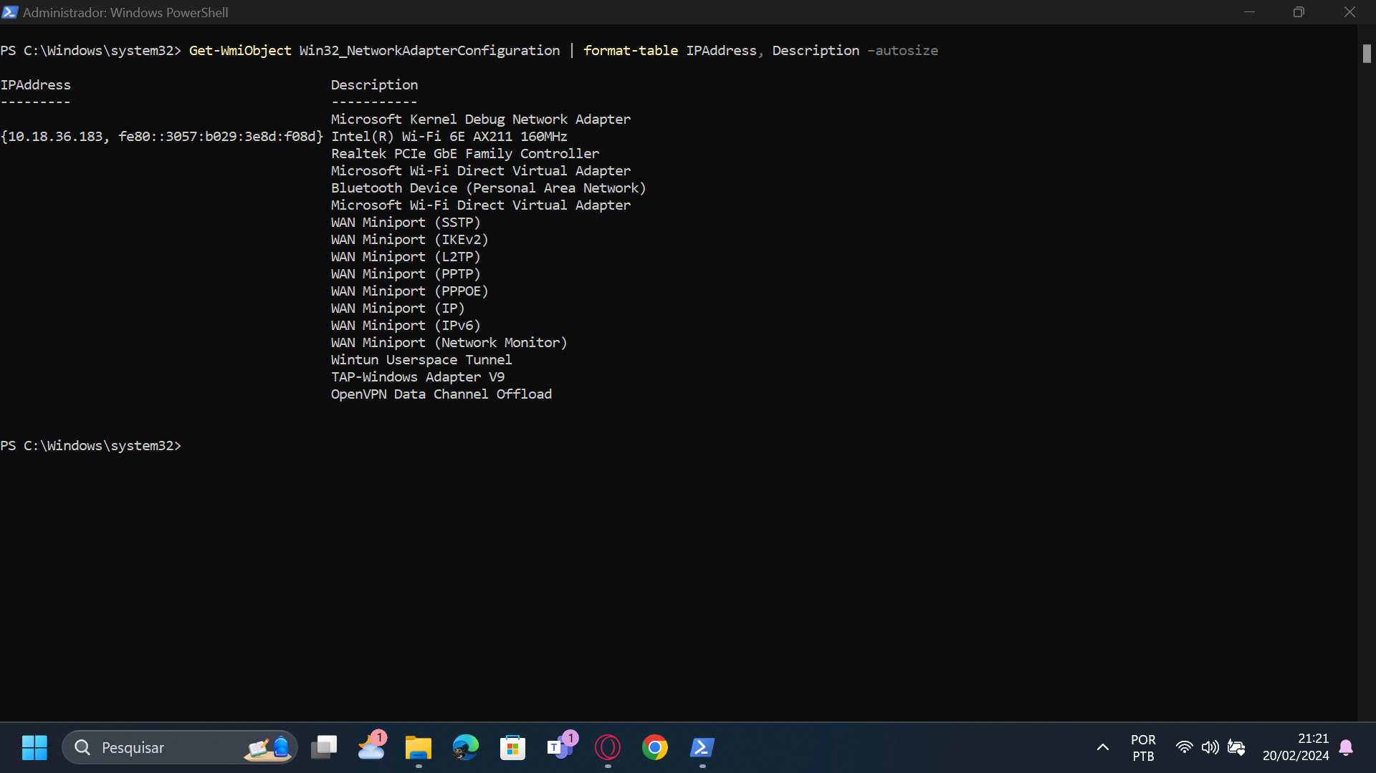  
  
get-wmiobject Win32_NetworkAdapterConfiguration | format-table MacAddress, Description – autosize:  
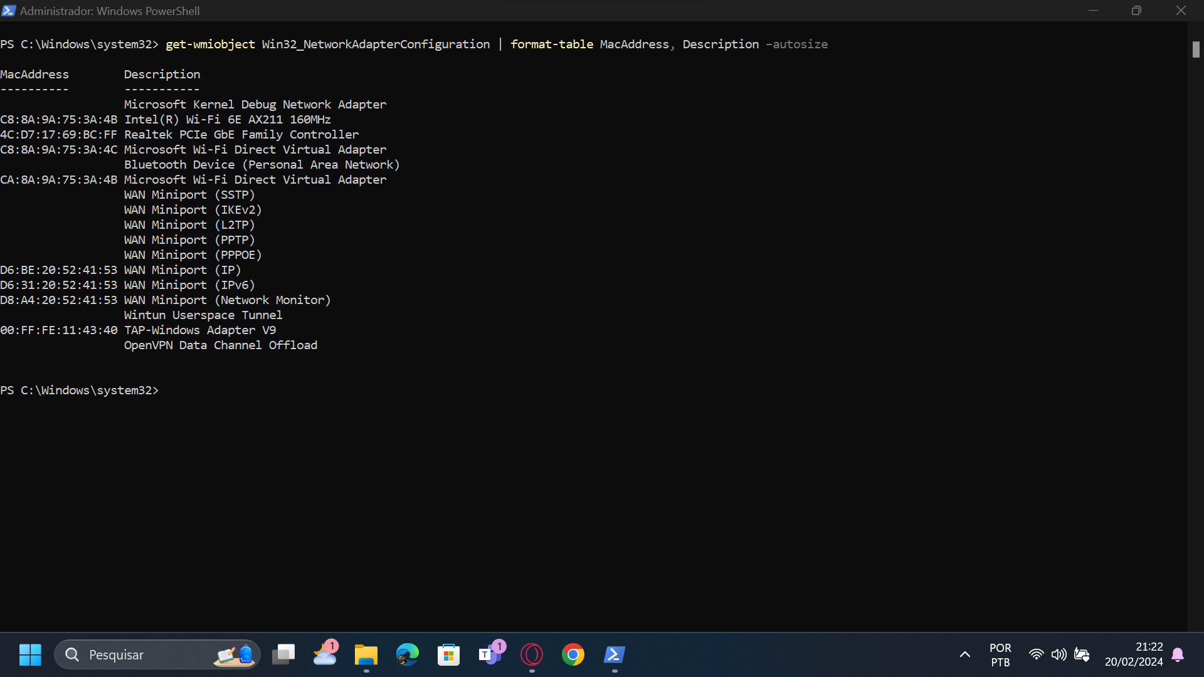  
  
Get-WmiObject -Class Win32_OperatingSystem:  
